

Credit Controller / Finance Assistant (Maternity Cover)
Recruitment Pack
https://www.sulets.com/jobs-at-sulets/

Re : Credit Controller

Thank you for your interest in the role of Credit Controller at Sulets. Please find contained in this recruitment pack the following:-

- Role Summary and Background
- Job Specification
- Person Specification

Please read the information provided. When applying, please provide a copy of your CV together with a covering letter outlining why you are applying for the position and how you meet the criteria within the Personal Specification, paying particular attention to the essential requirements.

Please return completed CVs and your Cover Letter to lisa@hackettconsultancy.co.uk.

Again, thank you for your interest in working for Sulets and we look forward to receiving your application.

Yours faithfully

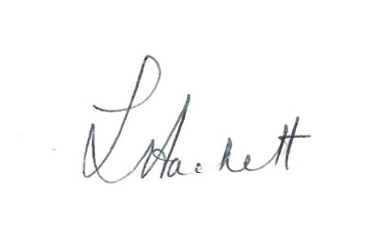
Lisa Hackett
On behalf of SULETS

ROLE SUMMARY AND BACKGROUND

Sulets is a leading highly trusted accommodation provider in Leicester and the only agency recommended by both universities. Offering quality accommodation at an affordable price with an honest service is central to the Sulets offer, with no hidden costs or agency fees. We were setup by our members, the Students’ Unions of De Montfort University and University of Leicester. We’re a not-for-profit organisation, this means that any funds we do raise will be invested straight back into the student experience.

We are currently recruiting for a Credit Controller on a fixed term contract for a minimum of 12 months to cover maternity leave with the potential to extend. This is a varied role and offers the opportunity to work on and off site with a variety of stakeholders. The ideal candidate will have experience in face to face contact with debtors and have a breadth of experience in credit control and working within a finance setting.

This is a full time role but part-time hours will be considered for the right candidate. A full handover will be provided along with ongoing training and support.

For an informal chat about the role please contact Irving Hill, CEO on 0116 4670 325.

For an application pack, please visit https://www.sulets.com/jobs-at-sulets/

CVs should be sent to Lisa Hackett at lisa@hackettconsultancy.co.uk.
Recruitment Schedule

Application deadline – Wednesday, 11 December 2019

JOB SPECIFICATION

Job title: Credit Controller

Department: Sulets

Salary: £22k per annum

Hours of Work: Monday to Friday, 37 hours per week (part time hours considered)

Responsible to: Senior Finance Assistant

MAIN DUTIES AND RESPONSIBILITIES

- Chasing debt for rent and associated payments by phone, written correspondence and in person.

- Working closely with site supervisors to effectively chase debt.

- Providing accurate debtor information to Solicitors and occasional attendance at Court as required.

- Daily debt reporting to internal Senior Management Team and Site Supervisors.

- Daily bank account upload and reconciliation including resolution of queries.

- Daily debtor and creditor reconciliation in LetMC (rent collection system).

- Producing and processing manual journals.

- Produce payment reports, raise invoices and process payments

- Raise contractor invoices and process payments

- Work closely with internal colleagues and external stakeholders to resolve queries.

- General office administration and finance duties.

- Any other duties associated with the role.

This job specification is subject to alteration after consultation with the post holder following any change in circumstances

October 2019

PERSON SPECIFICATION

Job title: Credit Controller

Department: Sulets

SKILLS/COMPETENCIES REQUIRED  All experience may be paid or voluntary, full or part-time, in the UK or overseas. | ESSENTIAL | DESIRABLE
Qualifications  - Good general education to GCSE Level  - Evidence of Continued Professional Development | √ | √
Experience  Previous credit control experience involving direct contact with debtor  - Experience in financial monitoring and control  - Good knowledge of financial controls  - Experience of working in a team  - Experience of recruiting and training staff  - Computer literate, with good knowledge of Microsoft office products, particularly Excel  - Experience of reconciling complex accounts  - Experience of facilitating difficult conversations | √  √  √  √  √  √  √  √
Skills/Abilities  Able to develop long and short term development plans  - Expert financial and administration skills  - Excellent attention to detail  - Excellent communication and time management skills  - Be able to prioritise workload effectively and efficiently, meeting deadlines as required  - Ability to remain calm whilst working under pressure | √  √  √  √  √  √

